Software Requirements Specification

Version V3.0

Facial Feature Based Attendance System

Client: OMNO.AI

Team #5

KrK

**Table of Contents**

Revision History 4

1. Introduction 5

1.1 Product 5

1.2 Scope 5

1.3 Business Goals 5

1.4 Document Conventions 5

1.5 References 6

2. Overall Desccription 7

2.1 Product Features 7dv

2.2 User Classes and Characteristics 7

2.2.1 Administrator 7

2.2.2. HR Staff 7

2.2.3. Employee 7

2.3 Operating Environment 8

2.4 Design and Implementation Constraints 8

2.5 Assumptions and Dependencies 8

3. Functional Requirements 9

3.1 Mark attendance 9

3.2 View Personal Attendance Report 9

3.3 View any Employee’s Attendance Report 10

3.4 Register New Employee 11

3.5 View All Visitors’ Report 12

3.6 Unregister Employees 12

3.7 Mark Manual Attendance 13

3.8 View Personal Visitors’ Report 14

3.9 Mark Visitor’s Reference 14

3.10 Configure Settings 15

4. Nonfunctional Requirements 16

4.1 Performance Requirements 16

4.1.1 Attendance mark with face detection, Detect Visitor 16

4.1.2 Detect underwork, Detect overwork 16

4.1.3 View stat reports for employees and visitors 16

4.1.4 Register Employee 17

4.2 Security Requirements 17

5. Other Requirements 17

1. Appendix A: Glossary 18

2. Appendix B: Analysis Models 19

5.1 Use Cases Diagram 19

5.2 Entity-Relationship Diagram 20

5.3 Data Flow Diagram (All Levels) 21

5.4 Class Diagram 24

3. Appendix C: Design Models 25

5.5 Component Diagram 25

4. Appendix D: Screenshots 26

3. Appendix E: Test Cases 31

1.1 Mark Entry 31

1.2 Mark Exit 31

1.3 Detect Visitor 31

1.4 Mark Manual Attendance 32

1.5 View personal attendance - Normal 32

1.6 View any employees’ report - Default 34

1.7 View any employees’ report - Underwork 34

1.8 View any employees’ report - Overwork 35

1.9 Register new employee 35

1.10 Unregister Employee 36

1.11 View all visitors’ report 36

1.12 View all visitors’ report - Employee Reference 37

1.13 View personal visitors’ report 37

1.14 Configure settings - Valid 38

1.15 Configure settings – Invalid-I 38

1.16 Configure settings – Invalid-II 39

1.17 Performance Requirements – Reporting 39

1.18 Performance Requirements – Mark Attendance 39

1.19 Performance Requirement - Register 40

1.20 Security - Admin 40

1.21 Security - HR-Manager 40

4. Appendix F: IV & V Report 41

5. Appendix G: Risk Report 42

6. Appendix H: Activity Timesheet 43

7. Appendix I: Updated Project Plan 44

# Revision History

|  |  |  |  |
| --- | --- | --- | --- |
| **Name(s)** | **Date** | **Reason(s) For Change(s)** | **Version** |
| Harris Naeem | Sept 26, 19 | Updated Non-Functional Requirements | 0.1 |
| Sabir Ali | Sept 26, 19 | Updated Operating Environment and Assumptions | 0.2 |
| Hammad Ikhlaq | Sept 26, 19 | Added “Reset Password” Functional requirement and updated pre and post conditions | 0.3 |
| Abdur-Rehman Mushtaq | Sept 26, 19 | Updated Scope and Business goals | 0.4 |
| Ali Tahir | Sept 26, 19 | Identified grammatical mistakes, redundancies and missing use cases | 0.5 |
| Raphael Nazirullah | Sept 27, 19 | Added Project Plan | 1.0 |
| Sabir Hassan | Oct 20, 19 | Inclusion of DFD & Wireframes | 1.6 |
| Raphael Nazirullah | Oct 22, 19 | Inclusion of component diagram | 1.7 |
| Raphael Nazirullah | Oct 23, 19 | Inclusion of project plan | 1.8 |
| Harris Naeem | Oct 23, 19 | IV&V Report | 1.9 |
| All | Oct 24, 19 | Modifications of IV&V | 2.0 |
| All | Nov 23, 19 | Bug fixes from professor’s feedback | 2.1 |
| Raphael Nazirullah | Nov 23, 19 | Added TC-1 and TC-2 | 2.2 |
| Raphael Nazirullah | Nov 25, 19 | Added TC-3 to TC-8 | 2.3 |
| Raphael Nazirullah | Nov 26, 19 | Added TC-9 to TC-14 | 2.4 |
| Sabir Hassan | Nov 26, 19 | Added TC-15 and TC-21 | 2.5 |
| Hammad Ikhlaq | Nov 27, 19 | Added IV&V report | 2.6 |
| Abdur Rehman | Nov 28, 19 | Added updated diagrams in Appendix B and C | 2.7 |
| Raphael Nazirullah | Nov 29, 19 | Added updated project plan and updated risk report | 3.0 |

# Introduction

## Product

Facial Recognition based attendance system is a web application. This system marks the attendance of recognized employees and saves visitors’ information. Moreover, the system will generate monthly attendance, leaves, overtime and undertime reports of employees. Apart from this, the system will also generate monthly report of visitors.

## Scope

The scope of this software will be limited to the needs of OMNO.AI. The central database will be maintained in their own server. A dedicated hardware will be used to capture the image of an employee in order to mark him/her present (however, laptop camera will be used for evaluation purposes). The system will use *Siamese Neural Network* for One-Shot image recognition [1]. As an output, the system will generate the attendance report of every employee and other reports discussed in section 1.1.

## Business Goals

The business goals that are addressed by this project are the following:

* Streamline the process of employee attendance and keep visitors’ record
* Facilitate HR department manage employees by providing specialized reports
* Make employees access to attendance and hours worked record easier
* Make a user-friendly software

## Document Conventions

* First level heading: Times New Roman 18 Bold
* Second level heading: Times New Roman 14 Bold
* Third level heading: Times New Roman 12 Bold
* Body: Times New Roman 12
* Title: Times New Roman 36 Bold
* Keywords: Italic
* Line Spacing: 1.2
* One blank line after every paragraph

## References

[1] F. Schroff, D. Kalenichenko, and J. Philbin, “FaceNet: A unified embedding for face recognition and clustering.,” in *CVPR*, 2015, pp. 815–823.

[2] G. Ofualagba, O. Osas, I. Orobor, I. Oseikhuemen, and O. Etse, “Automated Student Attendance Management System Using Face Recognition,” vol. 5, pp. 31–37, 2018.

[3] E. Varadharajan, R. Dharani, S. Jeevitha, B. Kavinmathi, and S. Hemalatha, “Automatic attendance management system using face detection,” *2016 Online Int. Conf. Green Eng. Technol.*, pp. 1–3, 2016.

# Overall Description

## Product Features

Facial features-based attendance system is a web-based application. It uses just a single image to recognize the identity of an individual [1][2]. It automates the process of marking employee’s attendance [3] and calculates overtime and undertime of an employee. Upon entering and leaving the building, the system performs check-in and check-out procedure with the help of a camera that takes a picture of the individual, identifies the individual and marks the attendance. In case of identification failure, the system saves the visitor entry in database with timestamp. Furthermore, system provides monthly attendance, overtime, undertime, leaves and visitors report.

## User Classes and Characteristics

Our system will have three types of user:

1. Administrator
2. HR Staff
3. Employee

### 2.2.1 Administrator

The administrator would have complete access to the system functions. Administrator would be able to see any report that the system provides and admin can view the profile of any employee. In case of change of administrator, leaving administrator would be responsible for adding the new administrator in the system. No one else would be able to perform this task.

### 2.2.2. HR Staff

HR department would be able to see attendance, leaves, overtime and undertime reports of employees for performance review. HR staff would be responsible to add new employees and remove an employee from the system. HR staff can also view visitors’ information.

### 2.2.3. Employee

The employee would be able to check his/her attendance from anywhere anytime with the help of the internet. If the employee is not punctual about the check-in time at work, this system will help him/her to be punctual. Furthermore, employees can keep a record of their leaves.

## Operating Environment

Operating environment for the facial features-based attendance system is as listed below:

* A high-resolution camera (300ppi)
* Database Mongo DB
* Client server architecture
* Tensor Flow
* Python Django

## Design and Implementation Constraints

The response time of the product depends upon the process speed of the system associated with the camera and internet connection as the database is online so enough bandwidth should be available for online processing. There might be some factors which could act as a hindrance to system to recognize the face. For example, if a face is covered with mask or anything else, the system would fail to detect the person. Furthermore, the effectiveness of the system depends on the picture quality of the camera.

## Assumptions and Dependencies

* When the main source of power is off there is an alternative resource.
* Cameras will always be functional. If any camera has fault it would be replaced immediately otherwise main feature of the system will not work.
* The system linked with cameras will always be connected to the internet.

# Functional Requirements

## Mark attendance

|  |  |  |  |
| --- | --- | --- | --- |
| **Identifier** | | UC-1 | |
| **Purpose** | | System shall automatically mark attendance by recognizing the employee/HR managers or detect visitor through camera | |
| **Priority** | | High | |
| **Actors** | | Employee/HR managers/Visitor | |
| **Pre-conditions** | | User shall enter through the front door with their face uncovered.  Camera shall be activated | |
| **Post-conditions** | | Entry of employee will have been added in the database. | |
| **Typical Course of Action** | | | |
| **S#** | **Actor Action** | | **System Response** |
| **1** | User shall face “Entry” camera. | |  |
|  |  | | System shall take his/her picture and check if he/she is an employee  If yes, then their entry will be added in the attendance database, otherwise, the system treats him/her as visitor |
| **Alternate Course of Action** | | | |
| **S#** | **Actor Action** | | **System Response** |
| **3** | User shall face the “Exit” camera | |  |
|  |  | | System shall take his/her picture and check if he/she is an employee  If yes, system shall add their “exit time” in the database for that employee, otherwise, the system treats him/her as visitor |

**Table 1: UC-1**

## View Personal Attendance Report

|  |  |  |  |
| --- | --- | --- | --- |
| **Identifier** | | UC-3 | |
| **Purpose** | | System shall allow user to view his/her attendance/underwork/overwork between a specific duration | |
| **Priority** | | High | |
| **Actors** | | Employee, HR manager and Admin | |
| **Pre-conditions** | | User shall be logged in | |
| **Post-conditions** | | Attendance report shall be displayed on screen | |
| **Typical Course of Action** | | | |
|  | **Actor Action** | | **System Response** |
| **1** | User shall press “view attendance report” button | |  |
|  |  | | System shall show report page. |
| **2** | User shall select duration interval by setting “From” and “To” fields. | |  |
|  |  | | System shall show his/her attendance report if valid interval given; otherwise |
| **Alternate Course of Action 1** | | | |
|  | **Actor Action** | | **System Response** |
| **1** | User shall select “view reports” option | |  |
|  |  | | System shall show report page |
| **2** | User shall select duration interval and “Underwork” or “Overwork” option. | |  |
|  |  | | System shall show relevant report stats. |

**Table 2: UC-2**

## View any Employee’s Attendance Report

|  |  |  |  |
| --- | --- | --- | --- |
| **Identifier** | | UC-6 | |
| **Purpose** | | System shall allow HR manager to view his/her employee attendance/underwork/overwork  System shall allow Admin to view his/her employee/HR manager attendance/underwork/overwork/leaves | |
| **Priority** | | High | |
| **Actors** | | HR manager and Admin | |
| **Pre-conditions** | | User shall be logged in | |
| **Post-conditions** | |  | |
| **Typical Course of Action** | | | |
|  | **Actor Action** | | **System Response** |
| **1** | HR manager shall press attendance report button on homepage | |  |
|  |  | | System shall show attendance report options. |
| **2** | User shall select duration in “From” and “To” fields and select employees from either dropdown menu or list. | |  |
|  |  | | System shall show report according to the parameters chosen. |

**Table 3: UC-3**

## Register New Employee

|  |  |  |  |
| --- | --- | --- | --- |
| **Identifier** | | UC-7 | |
| **Purpose** | | System shall allow admin to register employee/HR manager/Admin and it shall allow HR manager to register employee/HR manager | |
| **Priority** | | High | |
| **Actors** | | Admin and HR managers | |
| **Pre-conditions** | | 10 pictures of employee who is to be registered shall be given to system  Employee who is to be registered shall not be already registered  Admin/HR manager shall be logged in | |
| **Post-conditions** | | System database shall have info of new employee stored | |
| **Typical Course of Action** | | | |
| **S#** | **Actor Action** | | **System Response** |
| **1** | Admin shall press register button on homepage | |  |
|  |  | | System shall go to the register page and ask about the details of employee/HR/Admin manager to be registered |
| **2** | Admin shall enter the details and press save button | |  |
|  |  | | System shall display the message “Employee successfully added in the system” |
| **Alternate Course of Action 1** | | | |
| **S#** | **Actor Action** | | **System Response** |
| **1** | HR manager shall press register button on homepage | |  |
|  |  | | System shall go to the register page and ask about the details of employee/HR manager to be registered |
| **2** | HR manager shall enter the details and press save button | |  |
|  |  | | System shall display the message “Employee successfully added in the system” |
| **Alternate Course of Action 2** | | | |
| **S#** | **Actor Action** | | **System Response** |
| **1** | User shall press register button on homepage | |  |
|  |  | | System shall go to the register page and ask about the details of the user to be registered |
| **2** | User shall enter the details and press save button | |  |
|  |  | | System shall display the message “Employee already registered” |

**Table 4: UC-4**

## View All Visitors’ Report

|  |  |  |  |
| --- | --- | --- | --- |
| **Identifier** | | UC-4 | |
| **Purpose** | | System shall allow Admin/HR manager to view visitors’ report | |
| **Priority** | | Medium | |
| **Actors** | | Employee and HR manager and Admin | |
| **Pre-conditions** | | Employee, HR manager and Admin shall be logged in | |
| **Post-conditions** | |  | |
| **Typical Course of Action** | | | |
| **S#** | **Actor Action** | | **System Response** |
| **1** | HR manager shall press attendance report button on homepage | |  |
|  |  | | System shall show attendance report page |
| **2** | User shall check “For all visitors” radio button and enter duration in “From” and “To” fields | |  |
|  |  | | System shall show his/her report according to the type selected |

**Table 5: UC-5**

## Unregister Employees

|  |  |  |  |
| --- | --- | --- | --- |
| **Identifier** | | UC-8 | |
| **Purpose** | | System shall allow Admin to unregister employee/HR manager  System shall allow HR manage to unregister employee | |
| **Priority** | | Medium | |
| **Actors** | | Admin and HR manager | |
| **Pre-conditions** | | User who is to be unregistered shall be registered  Admin/HR manager shall be logged in | |
| **Post-conditions** | |  | |
| **Typical Course of Action** | | | |
| **S#** | **Actor Action** | | **System Response** |
| **1** | User shall press unregister button on homepage | |  |
|  |  | | System shall go to unregister page System shall ask about Employee id of user to be registered |
| **2** | User shall enter the employee id and press process button | |  |
|  |  | | System shall unregister the user |
| **Alternate Course of Action** | | | |
| **S#** | **Actor Action** | | **System Response** |
| **1** | User shall press unregister button on homepage | |  |
|  |  | | System shall go to unregister page System shall ask about Employee id of user to be registered |
| **2** | User shall enter the employee id and press process button | |  |
|  |  | | System shall display message “Incorrect Employee id” |

**Table 6: UC-6**

## Mark Manual Attendance

|  |  |  |  |
| --- | --- | --- | --- |
| **Identifier** | | UC-9 | |
| **Purpose** | | System shall allow Admin/HR manager to mark the attendance manually | |
| **Priority** | | Medium | |
| **Actors** | | Admin and HR manager | |
| **Pre-conditions** | | User shall be logged in | |
| **Post-conditions** | |  | |
| **Typical Course of Action** | | | |
| **S#** | **Actor Action** | | **System Response** |
| **1** | User shall press mark attendance button on homepage | |  |
|  |  | | System shall go to mark attendance page System shall ask about Employee id of user to be marked |
| **2** | User shall enter the employee id and press process button | |  |
|  |  | | System shall mark the user attendance |

**Table 7: UC-7**

## View Personal Visitors’ Report

|  |  |  |  |
| --- | --- | --- | --- |
| **Identifier** | | UC-2 | |
| **Purpose** | | System shall allow Admin/HR manager to view visitors’ report | |
| **Priority** | | Low | |
| **Actors** | | Employee, HR manager or Admin | |
| **Pre-conditions** | | User shall be logged in | |
| **Post-conditions** | |  | |
| **Typical Course of Action** | | | |
| **S#** | **Actor Action** | | **System Response** |
| **1** | User shall press “view visitors’ report” button. | |  |
|  |  | | System shall show visitor’s report |

**Table 8: UC-8**

## Mark Visitor’s Reference

|  |  |  |  |
| --- | --- | --- | --- |
| **Identifier** | | UC-10 | |
| **Purpose** | | System shall allow Admin/HR manager to mark the reference of the visitor | |
| **Priority** | | Low | |
| **Actors** | | Admin and HR manager | |
| **Pre-conditions** | | User shall be logged in | |
| **Post-conditions** | |  | |
| **Typical Course of Action** | | | |
| **S#** | **Actor Action** | | **System Response** |
| **1** | User shall press mark reference button on homepage | |  |
|  |  | | System shall go to mark reference page System shall ask about name, phone number and reference of visitor |
| **2** | User shall enter the details and press process button | |  |
|  |  | | System shall add the reference |

**Table 9: UC-9**

## Configure Settings

|  |  |  |  |
| --- | --- | --- | --- |
| **Identifier** | | UC-4 | |
| **Purpose** | | System shall allow user to change password and phone number | |
| **Priority** | | Low | |
| **Actors** | | Employee, HR manager and Admin | |
| **Pre-conditions** | | User shall be logged in | |
| **Post-conditions** | | User’s profile info will be updated in system. | |
| **Typical Course of Action** | | | |
|  | **Actor Action** | | **System Response** |
| **1** | User shall press “Settings” button | |  |
|  |  | | System shall show settings page |
| **2** | User shall enter new values for one or more of the following fields: name, phone number, email ID. | |  |
|  |  | | System shall save updated info. |
| **Alternate Course of Action** | | | |
|  | **Actor Action** | | **System Response** |
| **1** | User shall press “Settings” button | |  |
|  |  | | System shall show settings page |
| **2** | User shall select change password option | |  |
|  |  | | System shall show password change options. |
| **3** | User shall enter “Old Password” and “New Password” | |  |
|  |  | | System shall verify old password. If successful, password change shall be confirmed. Otherwise, error shall be indicated on screen. |

**Table 10: UC-10**

# Nonfunctional Requirements

## Performance Requirements

### 4.1.1 Attendance mark with face detection, Detect Visitor

The system’s overall performance and core functionality shall depend on the facial feature encoding module. Which depends on:

1. Camera Quality
2. Face Occlusion
3. Face Detection
4. Facial Feature Encoding
5. **Camera Quality**

A camera which shall take picture with at least 300ppi (pixels per inch). image quality is the most important aspect as it shall determine the overall accuracy of the system.

1. **Face Occlusion**

Facial feature shall be effectively captured. Hiding one’s face, covering it in anyway shall result in system’s inability to mark attendance. Employees shall not cover their face when entering office.

1. **Face Detection**

The face detection algorithm shall be state of the art. It shall accurately detect faces 96 % of the time provided there is no occlusion and image quality of 300 ppi.

1. **Facial Feature Encoding**

The encoding algorithm shall be state of the art. It shall be 99% accurate depending on the face detection, face occlusion, and camera quality.

Provided that the above requirements are satisfied the attendance shall be marked 99% of the time and the visitors shall also be recorded 99% of the time.

### 4.1.2 Detect underwork, Detect overwork

1. Any employee who works under 10 hours as per the company’s policy will be marked as underwork
2. Any employee who works more than 10 hours will be marked as overwork

The time clock of the system should be according to the time zone.

### 4.1.3 View stat reports for employees and visitors

These functionalities will be 100% accurate as long as the server is up and running and the face detection module correctly identifies employees from outsiders.

### 4.1.4 Register Employee

Registration of a new employee shall require a minimum of one picture. However at least 10 pictures will be collected and fed into the system because considering the current number of employees in OMNO, which exceeds 20, a classifier shall be trained for better accuracy.

Moreover, the pictures provided by the employee should be at least 300ppi and without face occlusions. The registration process shall indefinitely take some time, since the training algorithm requires 5 hours of training, provided that the GPU is available. A safe estimate would be to consider 2 days, at max, before the employee is registered, after receiving the pictures.

The overall registration process shall require the following:

1. Good quality, occlusion free 10 images
2. 5 hours training time
3. GPU availability

After the joining of the employee there shall be 1week testing period to test whether the software is able to correctly mark the employee’s attendance. In the meantime, OMNO’s conventional thumbprint-based attendance system will be used, which shall also be used as a backup system in case of software failure.

## Security Requirements

The Admin, HR and employees will have different authentication to login. Employees shall view only their attendance. Admin and HR shall view attendance of all the employees, including their own. A user ID and password shall be required. If the password is lost or forgotten a formal request shall be emailed to admin to reset password and provide the new password.

Data confidentiality is promised by the company when requesting images from employees. Their pictures shall not be shared. If any employee considering their religious or cultural background refuses to provide their pictures, or show their face their attendance will be manually entered on a daily basis by the HR into our system, using a separate interface.

# Other Requirements

As a prerequisite this software shall require hardware installation, including installing cameras at the entry door of the software house. Legality regarding privacy shall be required, i.e. who will view the constant camera stream, shall the camera feed be recorded or stored, shall the data recorded be sold or shared elsewhere. Furthermore, providing a backup power of UPS5000-S Series (50 kVA to 800 kVA) **Uninterruptible Power System** resource in case of load shedding.

# Appendix A: Glossary

Admin Administrator

HR Human Resource

MongoDB no-sql oriented database

One Shot Face Detection Algorithm that uses only one image to recognize an Individual’s face

Ppi pixel per inch

Python Django Python framework for building Web applications

Tensorflow Python framework for training, deploying and integrating neural nets

# Appendix B: Analysis Models

## Use Cases Diagram

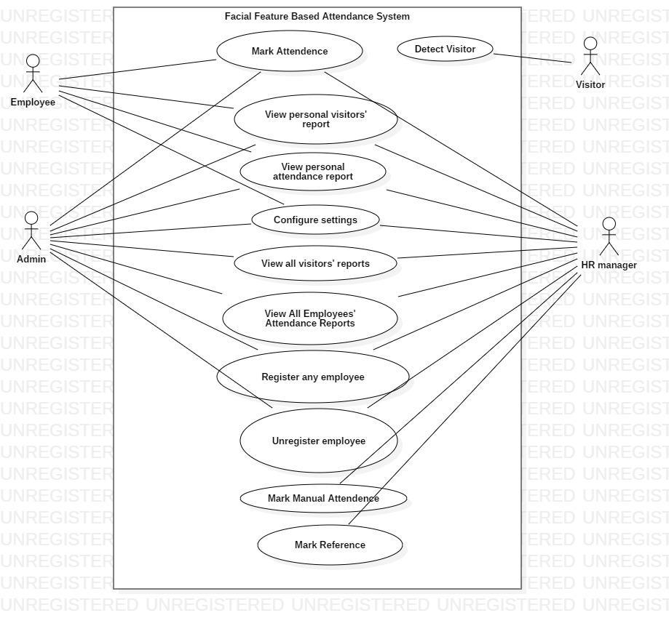

*Figure 1: Use Case Diagram*

## Entity-Relationship Diagram

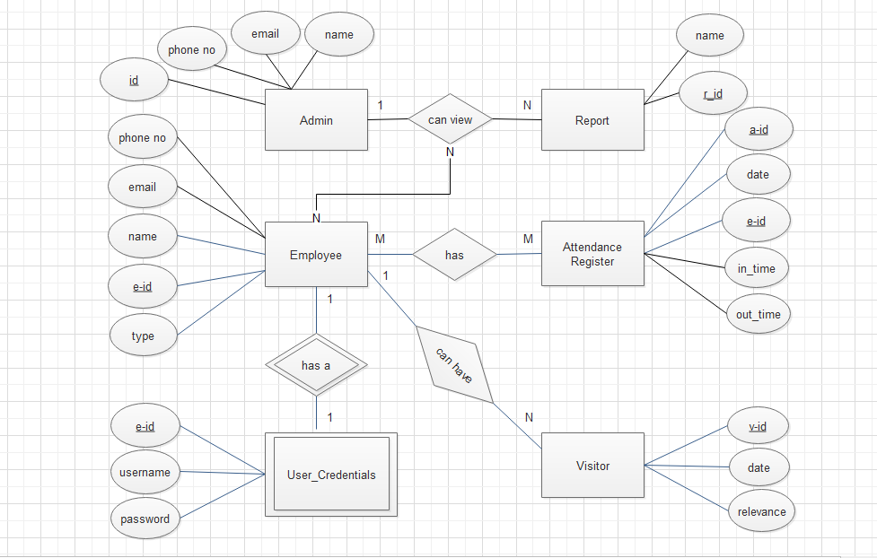

*Figure 2: Entity-Relationship Diagram*

## Data Flow Diagram (All Levels)

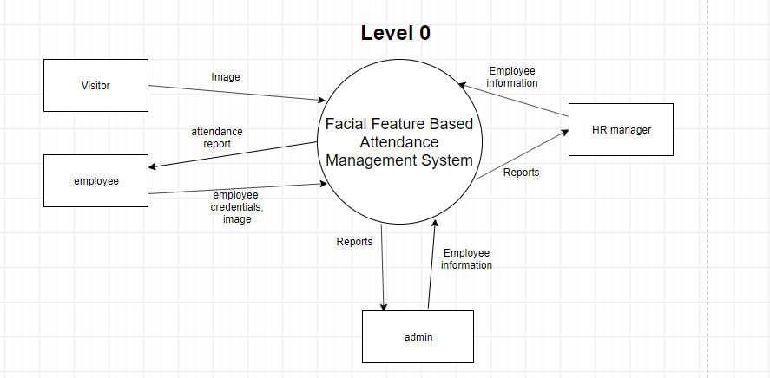

*Figure 3: DFD Level 0*

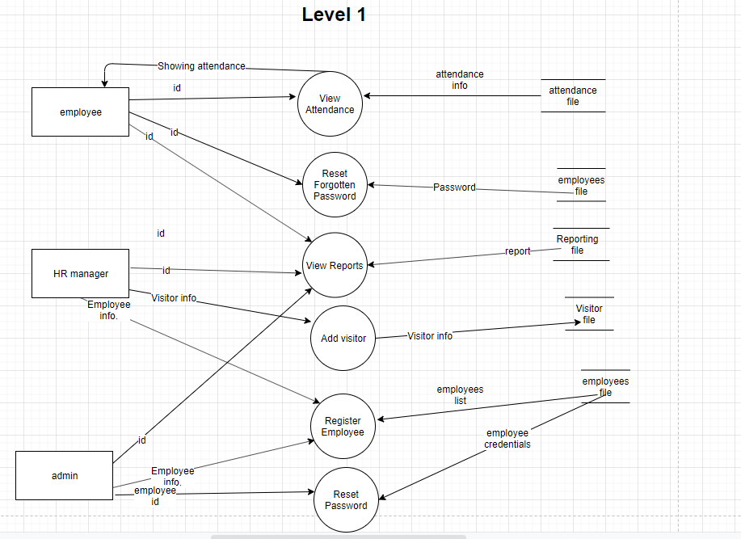

*Figure 4: DFD Level 1*

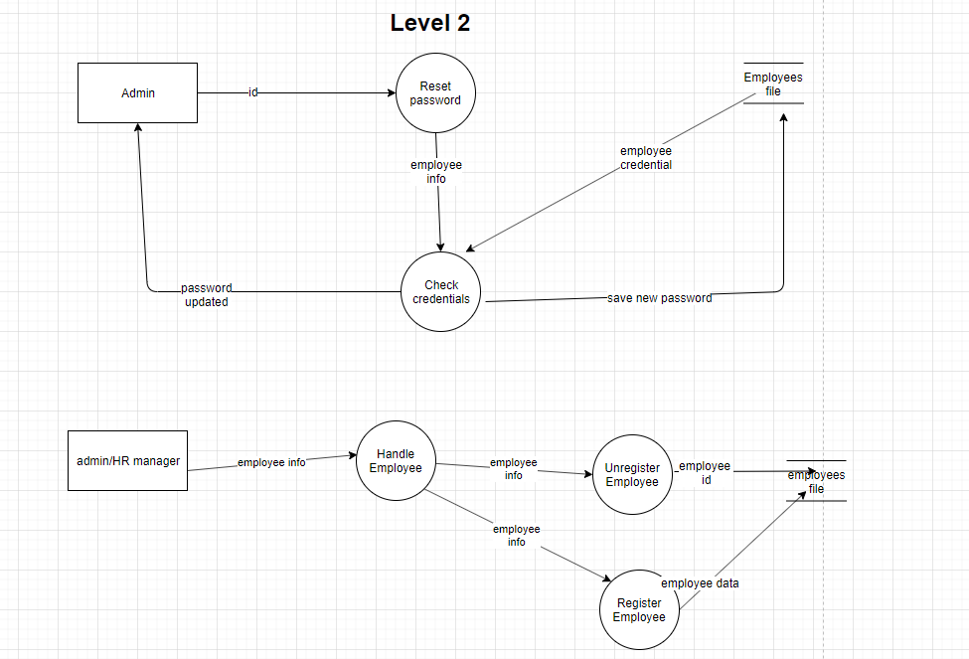

*Figure 5: DFD Level 2*

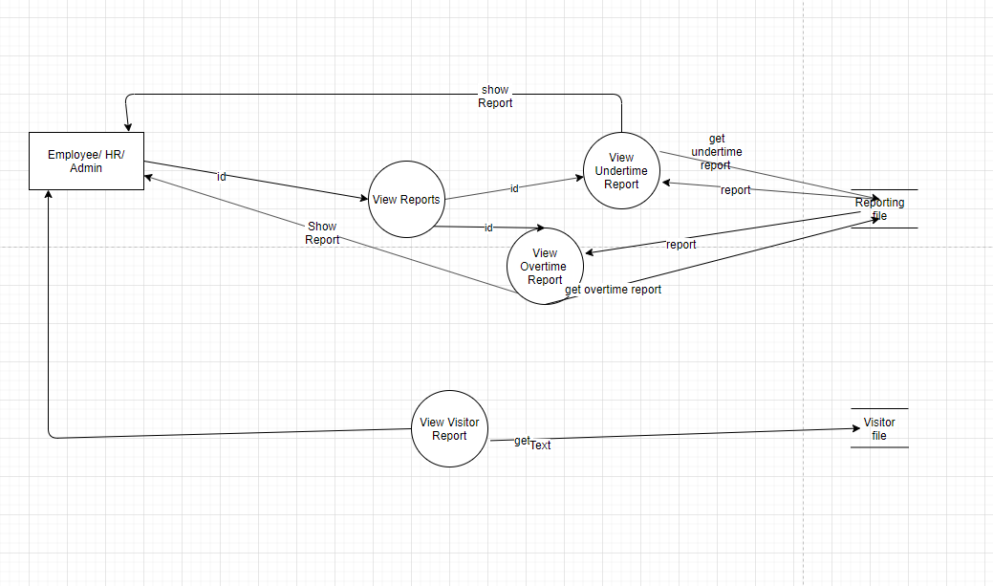

*Figure 6: DFD Level 2.2*

*Level 3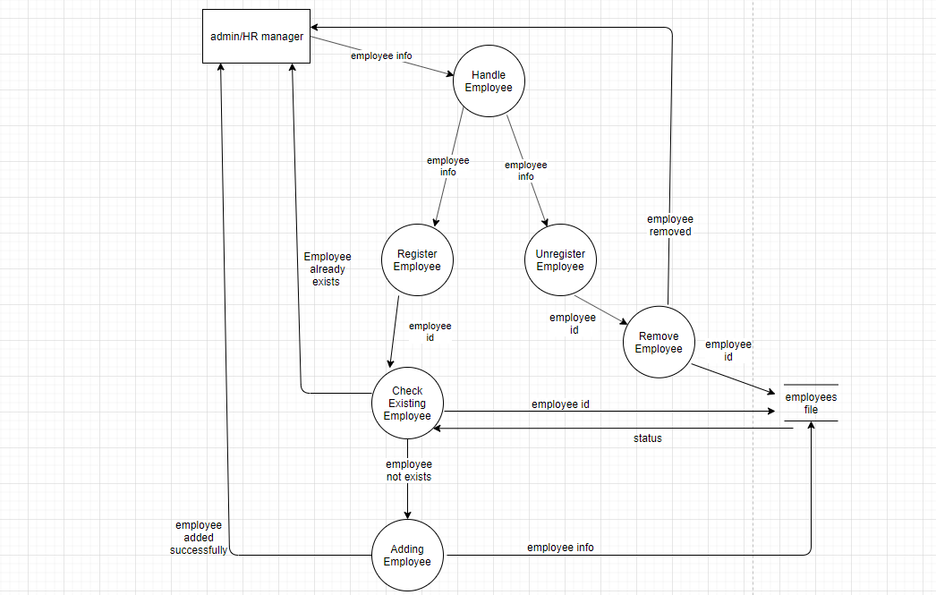Figure 8: DFD Level 3*

## Class Diagram

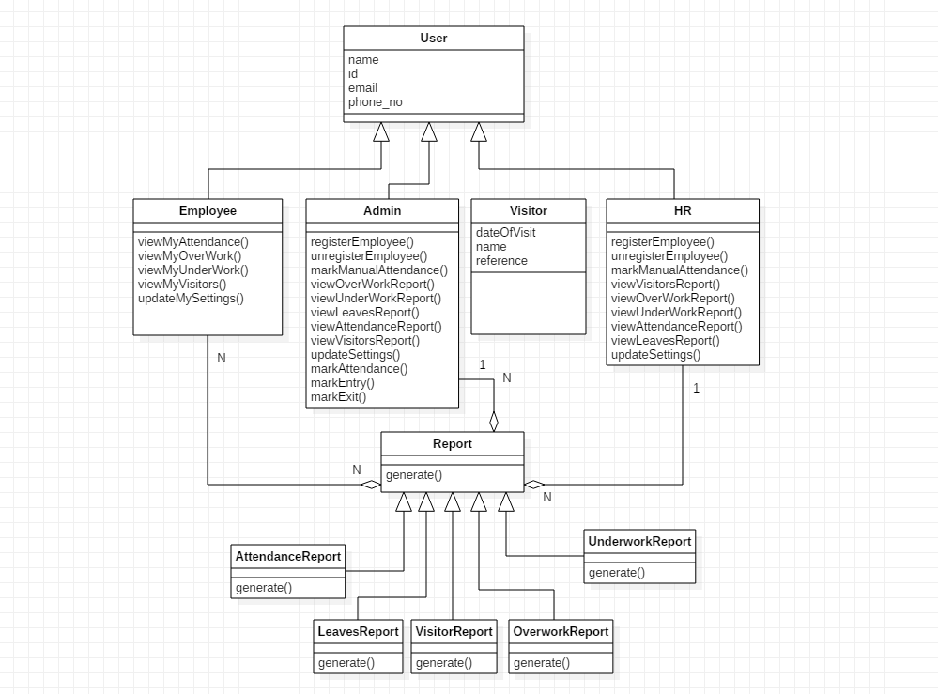

# Appendix C: Design Models

## Component Diagram

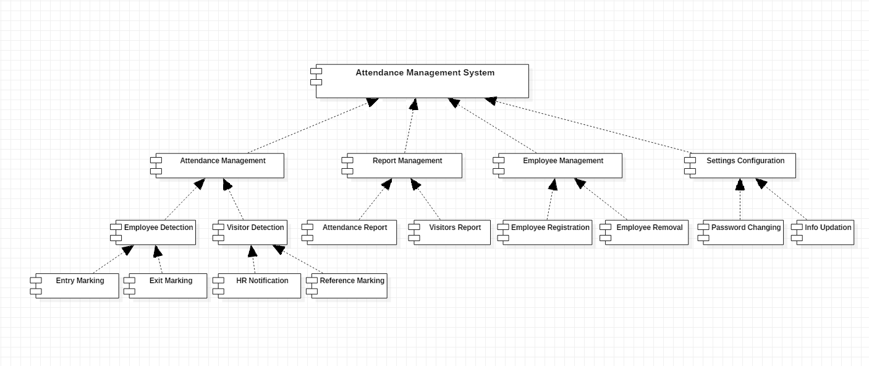

# Appendix D: Screenshots

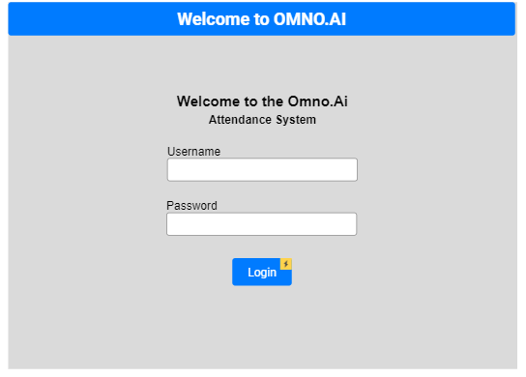

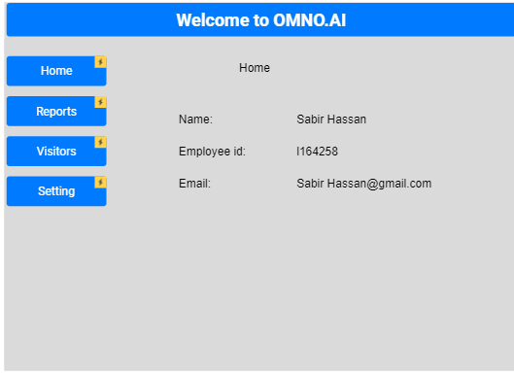

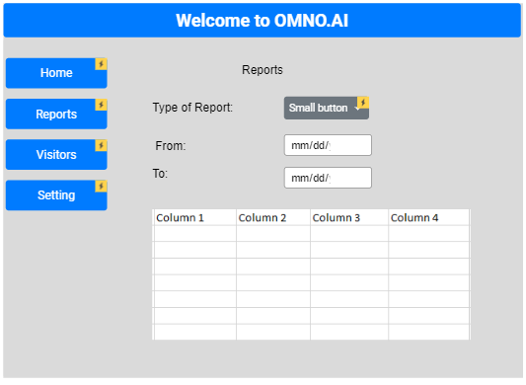



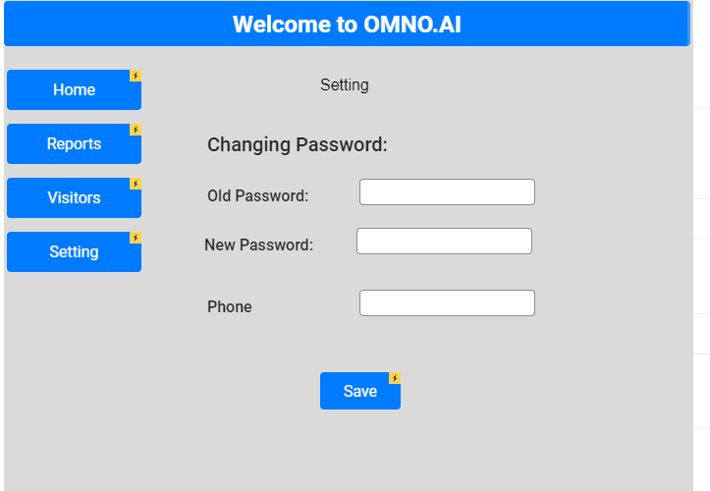

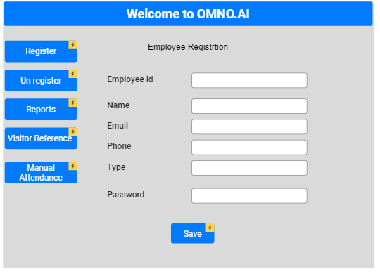

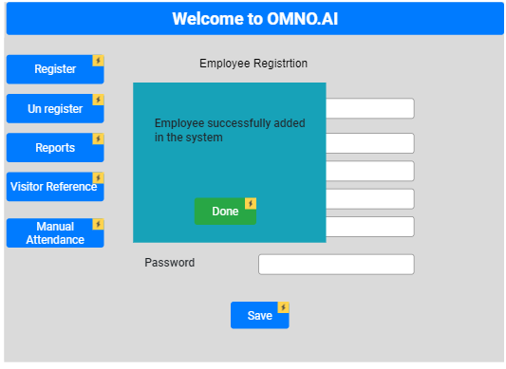

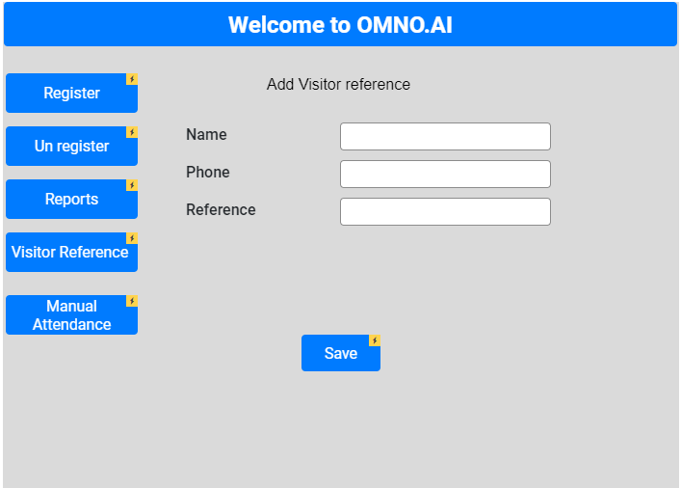

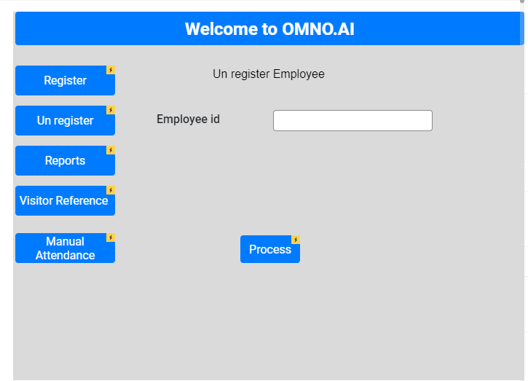

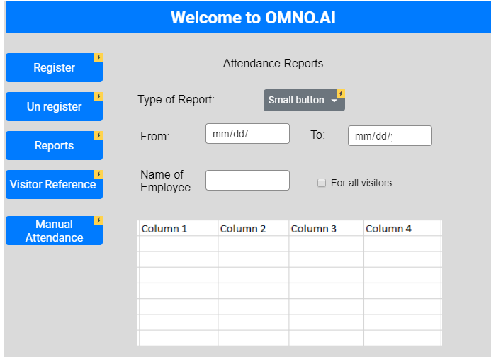

# Appendix E: Test Cases

## Mark Entry

|  |  |
| --- | --- |
| **Identifier** | TC-1 |
| **Priority** | High |
| **Related requirements(s)** | UC-1 |
| **Short description** | Testing employee’s entry being marked. |
| **Pre-condition(s)** | Employee is registered. Camera is active. System is running. |
| **Input data** | Image of Harris Naeem |
| **Detailed steps** | User stands in front of “Entry camera” and waits for image to be captured.  System captures image and displays message. |
| **Expected result(s)** | System displays “Harris Naeem”. |
| **Post-condition(s)** | Entry of Harris Naeem is added into database for current date/time. |

**Table 11: TC-Mark Entry**

## Mark Exit

|  |  |
| --- | --- |
| **Identifier** | TC-2 |
| **Priority** | High |
| **Related requirements(s)** | UC-1 |
| **Short description** | Testing employee’ exit being marked. |
| **Pre-condition(s)** | Employee is registered. Camera is active. System is running. |
| **Input data** | Image of Harris Naeem |
| **Detailed steps** | User stands in front of “Exit camera” and waits for image to be captured.  System captures image and displays message. |
| **Expected result(s)** | System displays “Harris Naeem”. |
| **Post-condition(s)** | “Exit” of Harris Naeem is added into database for correct date/time and corresponding entry time. |

**Table 12: TC-Mark Exit**

## Detect Visitor

|  |  |
| --- | --- |
| **Identifier** | TC-3 |
| **Priority** | Low |
| **Related requirements(s)** | UC-1 |
| **Short description** | Testing (unregistered) visitor detection. |
| **Pre-condition(s)** | Camera is active. System is running. |
| **Input data** | Image of Abdur Rehman |
| **Detailed steps** | User stands in front of camera (either “Entry/Exit mode) and waits for image to be captured.  System captures image and displays message of visitor detected. |
| **Expected result(s)** | System displays “Visitor detected”. |
| **Post-condition(s)** | No automatic entry is added into database. Manual attendance use case (UC-9), acted upon by HR, would handle further actions. |

**Table 23: TC-Detect Visitor**

## Mark Manual Attendance

|  |  |
| --- | --- |
| **Identifier** | TC-4 |
| **Priority** | High |
| **Related requirements(s)** | UC-7 |
| **Short description** | In case employee detection from camera fails, HR marks employee attendance manually in system. |
| **Pre-condition(s)** | Employee is registered.  Camera is active. System is running.  User (HR/Admin) is on “Manual Attendance” tab. |
| **Input data** | Employee name: Sabir Hassan Option: “Entry” or “Exit” value. |
| **Detailed steps** | 1. User selects employee name from list.  2. User selects one of two options: (Entry/Exit)  3. User clicks on “Mark attendance” button. |
| **Expected result(s)** | System shows “Attendance marked” message with corresponding record entered. |
| **Post-condition(s)** | Database shows corresponding entry of “Sabir Hassan” for today at a time value 5 minutes less than the current time. |

**Table 24: TC-Mark manual attendance**

## View personal attendance - Normal

|  |  |
| --- | --- |
| **Identifier** | TC-5 |
| **Priority** | High |
| **Related requirements(s)** | UC-2 |
| **Short description** | System shows employee’s attendance report according to the options chosen. |
| **Pre-condition(s)** | User is logged in. |
| **Input data** | “From” date: 1 week prior to “today” “To” date: Today “Default” value from the 3 attendance options: Underwork, Overwork, Default (User ID is also given as input implicitly since user is already logged in) |
| **Detailed steps** | 1. User sets the “From” date field from the interface date picker.  2. User sets the “To” date field from the interface date picker.  3. User leaves “View mode” to “Default”.  4. User selects “Show report” |
| **Expected result(s)** | System displays all entry/exit records for the given time. Each record shows “date”, “time in”, “time out”. |
| **Post-condition(s)** | No change in system’s internal state. |

**Table 13: TC-View Personal Attendance-I**

## View any employees’ report - Default

|  |  |
| --- | --- |
| **Identifier** | TC-6 |
| **Priority** | High |
| **Related requirements(s)** | UC-3 |
| **Short description** | System displays reports of selected employees’ |
| **Pre-condition(s)** | User is logged in and user must be admin or manager. |
| **Input data** | “From” date: 1 week prior to “today” “To” date: Today “Default” value from the 3 attendance options: Underwork, Overwork, Default Employee IDs of “Harris Naeem” or “Sabir Hassan” |
| **Detailed steps** | 1. User sets the “From” date field from the interface date picker.  2. User sets the “To” date field from the interface date picker.  3. User leaves “View mode” to “Default”.  4. User selects “Harris Naeem” or “Sabir Hassan” from employees list.  5. User presses “Show reports” button. |
| **Expected result(s)** | System displays attendance stats of Harris Naeem or Sabir Hassan of previous 1 week. |
| **Post-condition(s)** | No change in system’s internal state. |

**Table 15: TC-View employees’ report-I**

## View any employees’ report - Underwork

|  |  |
| --- | --- |
| **Identifier** | TC-7 |
| **Priority** | High |
| **Related requirements(s)** | UC-3 |
| **Short description** | System displays reports of selected employees for “Underwork” criterion. |
| **Pre-condition(s)** | User is logged in and user must be admin or manager. |
| **Input data** | “From” date: 1 week prior to “today” “To” date: Today “Underwork” value from the 3 attendance options: Underwork, Overwork, Default Employee IDs of “Harris Naeem” or “Sabir Hassan” |
| **Detailed steps** | 1. User sets the “From” date field from the interface date picker.  2. User sets the “To” date field from the interface date picker.  3. User selects “Underwork” from options.  4. User selects “Harris Naeem” and “Sabir Hassan” from employees list.  5. User presses “Show reports” button. |
| **Expected result** | System displays “Underwork” stats of Harris Naeem or Sabir Hassan of previous 1 week. |
| **Post-condition(s)** | No change in system’s internal state. |

**Table 16: TC-6**

## View any employees’ report - Overwork

|  |  |
| --- | --- |
| **Identifier** | TC-8 |
| **Priority** | High |
| **Related requirements(s)** | UC-3 |
| **Short description** | System displays reports of selected employees for “Overwork” criterion. |
| **Pre-condition(s)** | User is logged in and user must be admin or manager. |
| **Input data** | “From” date: 1 week prior to “today” “To” date: Today “Overwork” value from the 3 attendance options: Underwork, Overwork, Default Employee IDs of “Harris Naeem” and “Sabir Hassan” |
| **Detailed steps** | 1. User sets the “From” date field from the interface date picker.  2. User sets the “To” date field from the interface date picker.  3. User selects “Overwork” from options.  4. User selects “Harris Naeem” or “Sabir Hassan” from employees list.  5. User presses “Show reports” button. |
| **Expected result** | System displays “Overwork” stats of Harris Naeem or Sabir Hassan of previous 1 week. |
| **Post-condition(s)** | No change in system’s internal state. |

**Table 17: TC-7**

## Register new employee

|  |  |
| --- | --- |
| **Identifier** | TC-9 |
| **Priority** | High |
| **Related requirements(s)** | UC-4 |
| **Short description** | System stores info of a new employee into database. |
| **Pre-condition(s)** | Admin/HR is on “Add employee” tab/page. |
| **Input data** | Employee name: Ali Tahir Username: ali_tahir  Email ID: [ali@gmail.com](mailto:ali@gmail.com) Phone number: 1234567 Password: 123456 |
| **Detailed steps** | 1. User enters data into the form fields for name, email ID, phone number and password.  2. User clicks on “Register” button. |
| **Expected result** | System shows “Employee registered” along with newly assigned employee ID. |
| **Post-condition(s)** | System’s database has info of new employee stored and a new employee ID has been created. Database shows record of “Ali Tahir” in Employees database. |

**Table 18: TC-Add Employee**

## Unregister Employee

|  |  |
| --- | --- |
| **Identifier** | TC-10 |
| **Priority** | Low |
| **Related requirements(s)** | UC-6 |
| **Short description** | System removes info of an employee into database. |
| **Pre-condition(s)** | Admin/HR is on “Remove employee” tab/page. |
| **Input data** | Employee name: Ali Tahir (Employee ID given as input implicitly) |
| **Detailed steps** | 1. User selects Employee Name and ID from list.  2. User clicks on “Remove Employee” button.  3. System asks for confirmation.  4. User confirms by clicking in dialogue box. |
| **Expected result** | System shows “Employee removed” along with employee ID of removed employee. |
| **Post-condition(s)** | System database no longer shows record of removed employee. |

**Table 19: TC-Remove Employee**

## View all visitors’ report

|  |  |
| --- | --- |
| **Identifier** | TC-11 |
| **Priority** | Medium |
| **Related requirements(s)** | UC-5 |
| **Short description** | System displays records of all non-employees who visited company building. |
| **Pre-condition(s)** | Admin/HR is on “Visitors” tab/page. |
| **Input data** | “From”: Yesterday  “To”: Today “Employee Reference”: None |
| **Detailed steps** | 1. User selects “From” date.  2. User selects “To” date.  3. User leaves “Employee Reference” to “None”.  4. User clicks on “Show reports” button. |
| **Expected result** | System shows records of all visitors of since yesterday. |
| **Post-condition(s)** | No change in system’s internal data. Info is being displayed visitors. |

**Table 20: TC-View Visitors' Report-I**

## View all visitors’ report - Employee Reference

|  |  |
| --- | --- |
| **Identifier** | TC-12 |
| **Priority** | Medium |
| **Related requirements(s)** | UC-5 |
| **Short description** | System displays records of only those visitors who came from the reference of particular employees. |
| **Pre-condition(s)** | Admin/HR is on “Visitors” tab/page. |
| **Input data** | “From”: 2 months prior  “To”: Today “Employee Reference”: Harris Naeem, Sabir Hassan |
| **Detailed steps** | 1. User selects “From” date.  2. User selects “To” date.  3. User selects “Harris Naeem” and “Sabir Hassan” from employee references.  4. User clicks on “Show reports” button. |
| **Expected result** | System shows records of all visitors in given interval who came on the reference of Harris Naeem and Sabir Hassan. |
| **Post-condition(s)** | No change in system’s internal data. Info is being displayed visitors. |

**Table 21: TC-Visitors' report-II**

## View personal visitors’ report

|  |  |
| --- | --- |
| **Identifier** | TC-13 |
| **Priority** | Medium |
| **Related requirements(s)** | UC-8 |
| **Short description** | System displays records of only those visitors who came from the reference of the logged in employee. |
| **Pre-condition(s)** | User is on “Visitors” tab/page. |
| **Input data** | “From”: 5 months prior  “To”: 1 month prior |
| **Detailed steps** | 1. User selects “From” date.  2. User selects “To” date.  3. User clicks on “Show reports” button. |
| **Expected result** | System shows records of all visitors of since yesterday who came on the reference of Harris Naeem and Sabir Hassan. |
| **Post-condition(s)** | No change in system’s internal data. Info is being displayed visitors. |

**Table 22: Personal Visitors' Report**

## Configure settings - Valid

|  |  |
| --- | --- |
| Identifier | TC-14 |
| Priority | Low |
| Related requirements(s) | UC-10 |
| Short description | User can update their own name, username, phone number etc. |
| Pre-condition(s) | User is logged in and on “Settings” tab/page. |
| Input data | Employee Name: Alpha Beta username: alpha.beta |
| Detailed steps | 1. User enters updated data into form fields of name and username.  2. Users clicks on “Update info” button. |
| Expected result(s) | System displays updated info of employee. |
| Post-condition(s) | System database has updated data of the user. |

**Table 25: TC-Configure settings**

## Configure settings – Invalid-I

|  |  |
| --- | --- |
| **Identifier** | TC-15 |
| **Priority** | Low |
| **Related requirements(s)** | UC-10 |
| **Short description** | User can update their own name, username, phone number etc. |
| **Pre-condition(s)** | User is logged in and on “Settings” tab/page. |
| **Input data** | Employee Name: ##%#^#* |
| **Detailed steps** | 1. User enters updated data into form field of name.  2. Users clicks on “Update info” button. |
| **Expected result(s)** | System displays validation error. |
| **Post-condition(s)** | Database info remains unchanged |

**Table 26: TC-Settings Invalid-I**

## Configure settings – Invalid-II

|  |  |
| --- | --- |
| **Identifier** | TC-16 |
| **Priority** | Low |
| **Related requirements(s)** | UC-10 |
| **Short description** | User can update their own name, username, phone number etc. |
| **Pre-condition(s)** | User is logged in and on “Settings” tab/page. |
| **Input data** | Password: 123 |
| **Detailed steps** | 1. User enters updated data into form field of name.  2. Users clicks on “Update info” button. |
| **Expected result(s)** | System displays error (Password minimum length error). |
| **Post-condition(s)** | Database info remains unchanged |

**Table 27: TC- Settings Invalid-II**

## Performance Requirements – Reporting

|  |  |
| --- | --- |
| **Identifier** | TC-17 |
| **Priority** | High |
| **Related requirements(s)** | NFR 4.1.2 |
| **Short description** | System displays the 100% right results of specified reports. |
| **Pre-condition(s)** | Server must be running and established the connection with firebase. |
| **Input data** | Type of report: Overwork, underwork, |
| **Detailed steps** | 1. User enters Id of the employee.  2. Users clicks on “Get Report” button. |
| **Expected result(s)** | System displays the report in tabular form. |
| **Post-condition(s)** | Database info remains unchanged |

**Table 28: TC- Performance Reporting**

## Performance Requirements – Mark Attendance

|  |  |
| --- | --- |
| **Identifier** | TC-18 |
| **Priority** | High |
| **Related requirements(s)** | NFR 4.1.1 |
| **Short description** | System mark the entrance entry and exit entry of only that person whose image is provided. |
| **Pre-condition(s)** | ML Component’s server must be running and established the connection with firebase. |
| **Input data** | Image of Haris Naeem |
| **Detailed steps** | 1. Haris Naeem shows the face to camera.  2. System recognizes the face and add attendance to database. |
| **Expected result(s)** | System Recognizes the Haris’ face and add entry to only Haris’ collection. |
| **Post-condition(s)** | Database info of attendance changed. |

**Table 29: TC- Performance Mark Attendance**

## Performance Requirement - Register

|  |  |
| --- | --- |
| **Identifier** | TC-19 |
| **Priority** | High |
| **Related requirements(s)** | NFR 4.1.3 |
| **Short description** | System administrator train the model on a new set of images. |
| **Pre-condition(s)** | System must have a GPU availability for training purpose and good quality pictures must be provided. |
| **Input data** | Image dataset |
| **Detailed steps** | 1. Path to employees’ dataset.  2. System trains the model on given dataset and save the model. |
| **Expected result(s)** | A machine learning model capable of employee recognizing is expected. |
| **Post-condition(s)** | Old machine learning model is replaced with new trained model. |

**Table 30: TC- Performance Register new employee**

## Security - Admin

|  |  |
| --- | --- |
| **Identifier** | TC-20 |
| **Priority** | High |
| **Related requirements(s)** | NFR 4.2 |
| **Short description** | Admin page will be shown to only admin user. |
| **Pre-condition(s)** | Server must be running and established the connection with firebase. |
| **Input data** | ID:1  Password12345678: |
| **Detailed steps** | 1. Admin enter his credentials.  2. And presses the login button. |
| **Expected result(s)** | System will redirect the admin to his home page. |
| **Post-condition(s)** | Database state remains unchanged. |

**Table 31: Security admin**

## Security - HR-Manager

|  |  |
| --- | --- |
| **Identifier** | TC-20 |
| **Priority** | High |
| **Related requirements(s)** | NFR 4.2 |
| **Short description** | Manager page will be shown to only Manager user. |
| **Pre-condition(s)** | Server must be running and established the connection with firebase. |
| **Input data** | ID:2  Password12345678: |
| **Detailed steps** | 1. Manger enter his credentials..  2. And presses the login button. |
| **Expected result(s)** | System will redirect the Manger to his home page. |
| **Post-condition(s)** | Database state remains unchanged. |

**Table 32: Security admin**

# Appendix F: IV & V Report

**IV & V Resource**

Name Hammad Ikhlaq Roll # 16L-4281 Signature

|  |  |  |  |  |  |
| --- | --- | --- | --- | --- | --- |
| **S#** | **Defect Description** | **Origin Stage** | **Status** | **Fix Time** | |
| **Hours** | **Minutes** |
| 1 | Inconsistent system name in different diagrams, Specialization of Employee entity was needed, missing of associations name in class diagram | Analysis & Design | Resolved |  | 43 |
| 2 | Machine learning component was not detecting and updating the database for unknown person | Implementation & Testing | Resolved |  | 10 |
| 3 | Attendance report was showing redundant present marks when looking at the attendance of himself/herself | Implementation & Testing | Resolved |  | 4 |
| 4 | There was no filter for overwork and underwork | Implementation & Testing | Resolved |  | 5 |

**Table 3: List of non-trivial defects**

# Appendix G: Risk Report

[1]**Project Risks**

|  |  |  |  |  |  |
| --- | --- | --- | --- | --- | --- |
| **Risk Description** | **Impact**  **(1 – 10)** | **Probability**  **(0 – 1)** | **[2]Risk**  **Exposure** | **Weeks Active** | **Mitigation Strategy** |
| Ali Tahir fell ill on Nov 25 due to which ML component work could have slowed down. | 8 | 0.8 | 6.4 | 2 days | Harris Naeem tried to work until Ali Tahir revived. |
| Computer Networks Lab exam on Monday, Nov 25, deterred performance of all group members over the weekend, which could’ve caused incomplete project by due date. | 7 | 0.8 | 5.6 | 3 days | Extra work had to be done and night stay at Sabir’s hostel to complete work. |
| Hammad Ikhlaq was unavailable for IV&V due to personal commitments for 2 days, due to which IV&V couldn’t commence early, possibly leading to delayed testing. | 5 | 0.9 | 4.5 | 2 days | Had to wait for him to be available for IV&V. Some of the V&V done by Project Manager. |

# Appendix H: Activity Timesheet

|  |  |  |
| --- | --- | --- |
| **Activity** | **Time** | |
| **Hours** | **Minutes** |
| Requirements Engineering | 0 | 0 |
| Analysis and Design | 2 | 30 |
| Implementation | 40 | 35 |
| Testing | 3 | 40 |
| Deployment | 0 | 0 |
| Project Management | 6 | 55 |
| IV & V | 4 | 33 |

**Project Manager**

Name: Raphael Nazirullah Roll # 16L-4059 Signature

# Appendix I: Updated Project Plan

**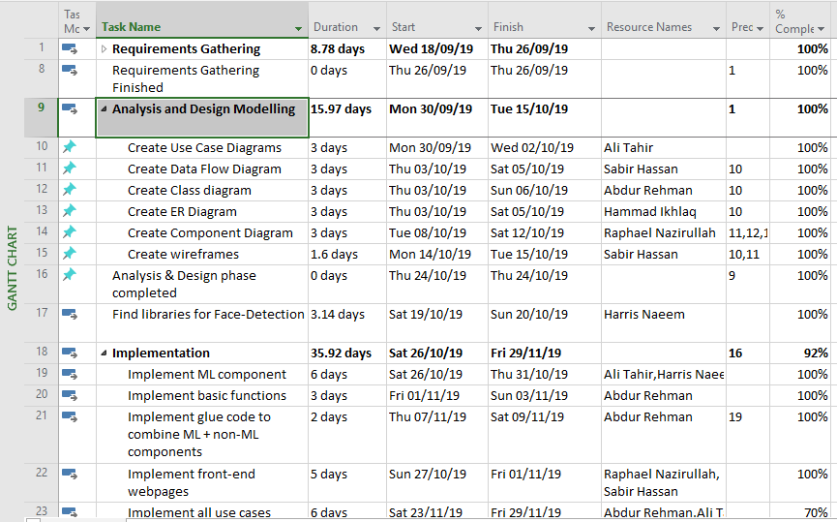  
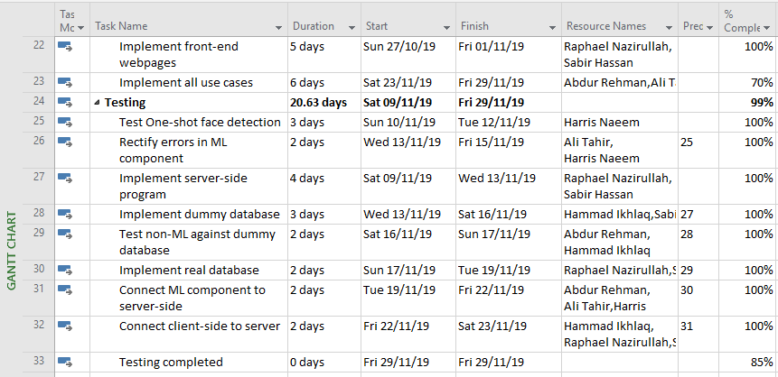**

**Gantt Charts**

**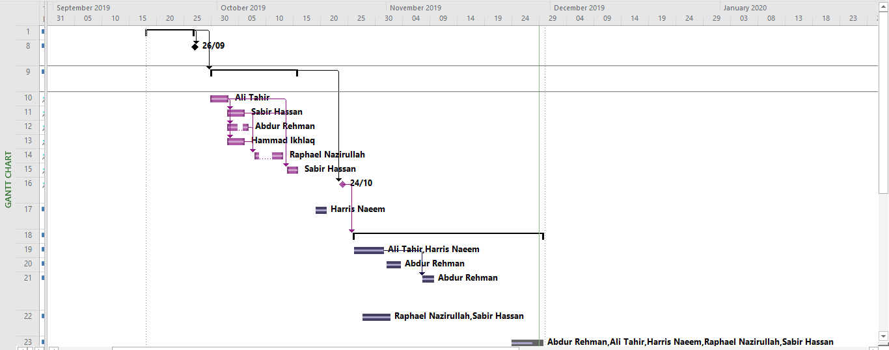  
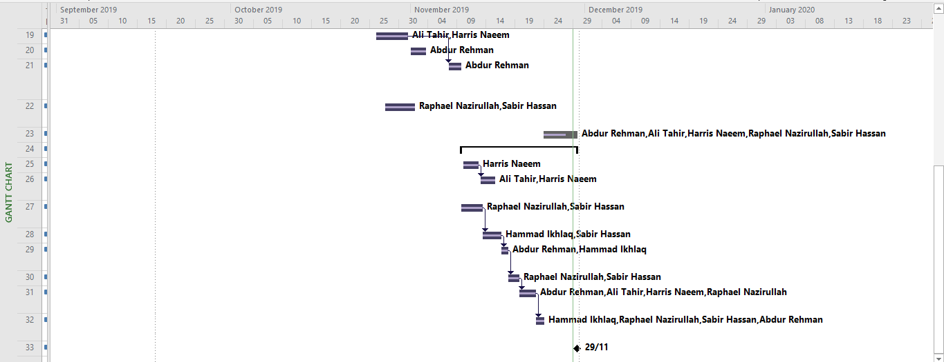**

1. Risks should be sorted in descending order of risk exposure.
2. Risk Exposure = Risk Impact x Risk Probability